IT13: ADBMS
Chapter 2:SQL
Practice Assignment Solution Template
Name:-Nikhil Nitesh Khude
Roll No:-2601105

Write a query and paste a screenshot of your output below the question.
- Create a database named CompanyDB.
Query:- create database CompanyDB;
use CompanyDB;
Output:-
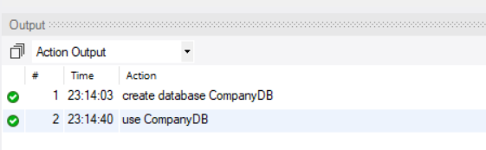

- Create a table Employees with the following columns:
Employees (EmpID (Integer, Primary Key), EmpName, Salary, JoinDate )
Query:- create table Employees(
EmpID Int Primary Key,
EmpName varchar(10),
Salary int,
JoinDate date);
Output:-
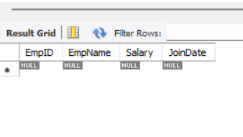

3.Create a table Departments with:
Departments (DeptID (Integer, Primary Key), DeptName)
Query:- create table department (
dept_id int primary key,
deptname varchar(10));
Output:-

4.Add a column Email (VARCHAR(100)) to the Employees table.
Query:- alter table Employees add column Email varchar(100);
Output:-
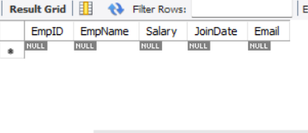

5.Add a column dept_location to the Departments table.
Query:- alter table department add column dept_location varchar(100);
Output:-
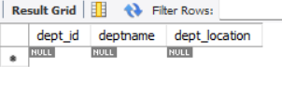

- Add a NOT NULL Constraint to the Phone column
Query:- alter table Employees add column Phone numeric not null;
Output:-

7.Change the size of the EmpName column from VARCHAR (50) to VARCHAR (100).
Query:-alter table Employees modify empname varchar(100);
Output:-

8.Drop the primary key Constraint from Departments
Query:- alter table department drop primary key;
Output:-

9.Create a foreign key constraint between two tables
Query:- alter table Employees add dept_id int ; alter table Employees add foreign key Employees(dept_id) references department (dept_id);
Output:-
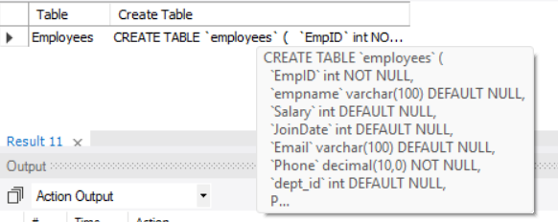

10.Rename the column EmpName to EmployeeName.
Query:- alter table Employees rename column empname to employeesname;
Output:-
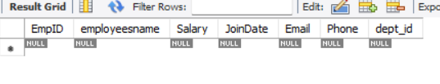

11.Apply a CHECK constraint on the Age and Salary columns.
Query:- alter table Employees add column age int ; alter table Employees add constraint chk_salary_age check(age>20 and salary>5000);
Output:-

12.Remove the Phone column from the Employees table.
Query:- alter table Employees drop Phone;
Output:-
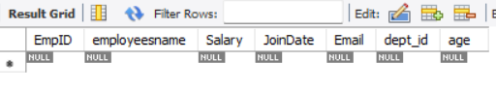

13.Rename the table Employees to EmployeeDetails.
Query:- rename table Employees to employeedetails;
Output:-

14.Drop the CHECK constraints.
Query:- alter table employeedetails drop check chk_salary_age;
Output:-

15.Delete the Departments table permanently.
Query:- drop table department;
Output:-


16.Drop the database.

Query:- drop database Company_DB;
Output:-

